Getting lost in the matrix? On how the characteristics and arrangement of linear landscape elements influence ecological connectivity

Calum Anderson 1,2, Justin M. J. Travis 1, Stephen C. F. Palmer 1, Humphrey Q. P. Crick 3, Lesley T. Lancaster 1,

1. University of Aberdeen, School of Biological Sciences, Zoology Building, Tillydrone Avenue, AB24 2TZ
2. **Email**: r01ca17@abdn.ac.uk, **Mobile**: +44 07507 464403
3. Natural England, Eastbrook, Shaftesbury Rd, Cambridge CB2 8DR

**Declarations**

**Funding**: This research was supported by the Natural Environment Research Council (NERC) [grant number NE/P009697/1]. Support was also received from Natural England (https://www.gov.uk/government/organisations/natural-england).

**Conflicts of interest**: none

**Ethics approval**: N/A

**Consent to participate**: N/A

**Consent to publication**: N/A

**Data availability**: the data reported this study are publicly available in a compressed folder at https://github.com/r01ca17/Anderson-TartanGraph-Connectivity-Matrices.

**Code availability**: the R-script code used to analyse raw data and produce the four graphs in the manuscript are included in the supplementary materials and at the same GitHub account as above.

**Author contributions**: all authors listed contributed to the writing and revision of the manuscript.

**Abstract**

**Context**: Linear landscape elements (LLEs) such as ditches and hedgerows can increase the ecological connectivity of habitat embedded within agricultural areas by acting as corridors for animal movement. However, we lack knowledge on how the spatial arrangement of LLEs influence dispersal, impeding our ability to offer robust advice on how best to add new LLEs to improve connectivity.

**Objectives**: To examine how the width and spatial orientations of LLEs composing an intersecting network might influence connectivity across landscapes.

**Methods**: We used an individual-based dispersal model to simulate the stochastic movement of small organisms through stylised LLEs of different characteristics. Landscapes were composed of two habitat patches separated by a grid-like network of LLEs composed of two types:   
**1**.) *connecting-edges* (touching patches on either end) and **2**.) *transecting-edges* (running perpendicular to *connecting-edges*). By altering the numbers and widths of each LLE type we sought to understand the effect of these variables on inter-patch dispersal rates.

**Results**: Increasing the number or width of *connecting-edges* improved connectivity but, conversely, increasing the number or width of *transecting-edges* reduced it. The greater freedom of movement offered by increasing numbers of *transecting-edges* may have inhibited connectivity, as individuals with limited perceptual-range were more likely to become trapped in complex networks and thus fail to navigate to suitable habitat patches.

**Conclusions**: The orientation of LLEs with respect to landscape resources greatly affects their impact on connectivity. The addition of LLEs to landscapes may decrease their connectivity for small, flightless species if they do not directly channel dispersers toward landscape resources.

**Keywords**: Connectivity, Corridor, Dispersal, RangeShifter, Individual-based model

Introduction

As socio-economic development often involves extensive modification of landscape structures to meet human needs, conservation efforts must often contend with the negative impacts of habitat destruction and fragmentation (Baldock, 1990; He *et al*., 2009; Scanes, 2018). One of the ways in which habitat loss negatively affects biodiversity and increases the extinction probability of remaining species is by reducing the overall carrying capacity of a landscape, as smaller populations are generally more vulnerable to the potentially negative impacts of demographic and environmental stochasticity (Lande, 1993; Fahrig, 1997; Newman and Pilson, 1997; Ovaskainen and Meerson, 2010).In a similar fashion, the fragmented distribution of remaining habitat may further endanger the viability of surviving populations by reducing them to even smaller sub-populations associated with the remnant habitat patches (Fahrig, 2003). Informed by the theoretical framework of meta-population dynamics, it has been suggested that effective conservation of a population distributed across patchy habitat may be pursued by improving the connectivity of their landscape (Taylor *et al*., 1993), thereby mitigating local extinction risks by permitting greater dispersal and hence demographic and genetic exchange between habitat fragments (Brown and Kodric-Brown, 1977; Hansson, 1991; Fahrig and Merriam, 1994; Hanski and Ovaskainen, 2000). Increasing connectivity might be achieved by the maintenance, improvement or creation of landscape elements that more readily permit long movements through the matrix, perhaps by providing less dangerous and/or energetically taxing routes of travel relative to the wider landscape, and thereby act as corridors through which individuals are more likely to successfully traverse hostile matrix (Tischendorf and Wissel, 1997).

Linear landscape elements (LLEs), such as hedgerows or ditches, are a common feature of developed agricultural landscapes and are often created primarily to serve socio-economic purposes, such as demarcating the boundaries of adjacent fields or controlling the hydrology of low-lying areas. As these LLEs can contain diverse vegetation profiles, often a signature of the landscape’s historical habitat (Forman and Gordon, 1981; Saunders *et al*., 1991), they may provide a more sheltered and hospitable environment for dispersing species than the exposed and highly disturbed arable, pastoral or urban elements of the wider matrix and thus be relatively permeable to the movement of small animals along their lengths (Merckx *et al*., 2010; Graham *et al*., 2018). LLEs such as fencerows, treelines and ditches have been documented to promote the connectivity of agricultural landscapes for a variety of small mammal and insect taxa (Fahrig and Merriam, 1985; Henderson *et al*., 1985; Mech and Hallett, 2001; Van Geert *et al*., 2010; Schulp *et al*., 2014). However, LLEs can fall short of providing adequate resources in which populations can maintain sustainable growth to the degree achieved in patches; for example, the diversity of arthropod taxa within LLEs, such as uncultivated field boundaries, declines with increasing distance from nearby source populations in remnant habitat patches (Ökinger and Smith, 2007; Jauker *et al*., 2009; Krewenka *et al*., 2011; Ekroos *et al*., 2013; Villemey *et al*., 2015). This may be due to the comparatively small carrying capacity and/or a greater vulnerability to edge effects of LLEs relative to habitat patches (Simberloff *et al*., 1992; Schalkwyk *et al*., 2020). Thus, though species can use LLEs as relatively permeable corridors for movement, they may not always be able to utilise LLEs as locations in which to permanently reside and reproduce (Pryke and Samways, 2001).

The configuration of LLE networks can vary substantially in density and continuity both between and within agricultural landscapes; the location of drainage ditches will reflect both the topography and hydrology of the terrain, whilst patterns of land-ownership determine where hedgerows are planted or maintained to act as barriers to livestock movement. Similarly, urban LLEs such as road or railway verges will reflect patterns of urban development that have rarely been planned with ecology in mind. LLEs will often intersect, for example, where they demarcate the corners of fields or roadway intersections (Joyce *et al*., 1999), and thereby collectively form a semi-continuous network composed of nodes and edges, varying in density and shape across the landscape (Mader *et al*., 1990).

The creation of additional novel LLEs in a network might be expected to increase connectivity by providing a greater abundance of corridors for dispersal and offering greater freedom of movement through a greater number of LLE nodes to avoid predators, forage and disperse to novel patches (Forman & Gordon, 1981). However, it might not always be so straightforward. For instance, in one of the only studies to date which experimentally tested the impact of LLE intersections on dispersal patterns, Eriksson *et al*. (2013) found that 50% of released bush-crickets (*Metrioptera roeseli*) would change their initial direction of travel through a linear grassy verge at least once upon encountering a node. This highlights a potential downside of the greater freedom of movement offered by a denser LLE network. An individual moving along a LLE in the direction of suitable habitat may be less likely to reach that habitat efficiently if it encounters nodes formed with transecting LLEs. This raises the possibility that too many LLEs in a network might potentially decrease landscape-wide connectivity by overwhelming individuals with redundant options for movement.

Increasing the width of LLEs may also have a similarly counterintuitive impact on their suitability as corridors for animal movement. Though wider ecological corridors can be easier for individuals to move through (Baur and Baur, 1992; Tischendorf *et al*., 1998) and hence broader LLEs might be expected to contribute positively to connectivity, there is also evidence that individuals can make larger lateral movements within wider corridors that extend their time taken to traverse its length, which in turn reduces their final likelihood of moving from one end of the feature to the other (Andreassen *et al*., 1996). This suggests that wider LLEs can be less effective in some regards as corridors to connect ecologically significant locations. We may observe here another example of how a greater freedom of movement (in this case *within* single LLEs) might negatively impact the connectivity of LLE networks if it induces individuals to move less efficiently through LLEs of larger dimensions.

Therefore, there is a need to gain improved understanding of how the number, characteristics and spatial arrangement of LLEs within a landscape impacts on connectivity between ecologically important sites.

Here, we developed in-silico experiments to investigate how varying the LLE network configuration between habitat patches in a synthetic, hypothetical landscape might affect connectivity. An individual-based model (IBM) of species movement was used to predict dispersal rates and thus connectivity across a series of landscapes. The experiments sought to determine how the configuration of a matrix composed of movement-permeable LLEs might affect connectivity by experimentally altering:

**1**) the number and width of LLEs *connecting patches to each other* and

**2**) the number and width of LLEs *transecting* the connecting LLEs to form a distribution of nodes.

This distinction was designed to reflect the grid-like structure of real LLE lattices where hedgerows, ditches or verges often intersect roughly at right angles, and where it is a frequent pattern to observe large, straight formations intersected throughout their lengths by numerous LLEs running in roughly perpendicular directions.

Methodology

Our modelling approach was to simulate the dispersal of many individuals from the habitat patch of their birth to another suitable habitat patch through landscapes comprising LLEs that provided high quality dispersal corridors through an otherwise impermeable matrix. By varying the density and spatial arrangements of the LLEs across sets of simulations we sought insights into how LLE characteristics enhance and/or inhibit successful dispersal and thus connectivity. To simulate individual movements between patches through these experimentally varied LLE networks, we used the Stochastic Movement Simulator (SMS; Palmer *et al*., 2011) provided within the ecological IBM software RangeShifter v. 2.0 (Bocedi et al., 2014). The SMS accounts for the ignorance and fallible judgement of individuals as they navigate landscapes to predict emergent patterns of connectivity. Naïve individuals respond to landscape structure within a limited range of perception, producing stochastic movement behaviours that can be quite different in characteristics to those obtained from the results of least-cost path or circuit theory-based models, which ignore the potential for dispersers to become lost or disoriented when moving through large and complex landscapes. In at least one study, SMS has been demonstrated to provide a better estimate of connectivity between patches than these alternative approaches (Coulon et al. 2015).

TartanGraphs

In order to investigate how the connectivity of an LLE network might be affected by its configuration, a series of simple, cell-based landscapes were created as inputs for RangeShifter. These landscapes consisted of identical, rectangular habitat patches arranged into pairs separated from each other by an impermeable matrix interrupted by a number of straight LLEs that allowed the movement of simulated individuals between the two patches. The LLEs were parametrised to have zero carrying capacity, thus preventing individuals from reproducing outside of the two patches, and excluding the LLEs as potential habitat.

**Figure 1**: Example of two TartanGraphs, habitat-patch cells displayed in blue and matrix cells in violet. White space is entirely inaccessible to individuals. **Left**: TartanGraph consisting of five connecting-edges and three transecting-edges. **Right**: TartanGraph consisting of five connecting-edges and 15 transecting-edges.

The matrices of different habitat pairs contained differing numbers of *connecting-edges*, terminating at either end at each patch, and *transecting-edges*, forming nodes with the *connecting-edges* on a perpendicular axis. Based on the pattern of intersecting lines created in these artificial landscapes, we dubbed these landscapes *TartanGraphs* (**Figure 1.**).

Each *TartanGraph* was identical in scale and distance between habitat patches, with each *connecting-edge* measuring 177 raster-cells in length and habitat patches measuring 17 cells in depth from the matrix boundary. The least-costly path of inter-patch dispersal made available to individuals by virtue of the *connecting-edges* was therefore identical on all graphs, requiring individuals to make at least 178 “steps” (a single movement from one cell into another) to disperse from their origin patch into the other. The cells between LLEs were set to “no data” values and thereby interpreted by the model as empty space, inaccesible to simulated individuals.

To investigate how LLE network density might affect connectivity, a set of 25 *TartanGraphs* containing networks consisting of every combination of a number of *connecting-edges* (five treatments: 3, 5, 9, 17 and 33) and *transecting-edges* (five treatments: 0, 3, 7, 15 and 31) were simulated and the numbers of both edge types used to analyse the impact of LLE number and orientation on connectivity. The *edges* in these landscapes were positioned to be roughly equally apart from one another and *edge* numbers were experimentally increased by inserting novel *edges* into the intervals between LLEs or between LLEs and the patch boundary (e.g. 16 new LLEs were added to the 17 *connecting-edge* maps to create *TartanGraphs* with 33 *connecting-edges*). This method of increasing *edge* numbers maintained a roughly equal distance between LLEs as *edge* numbers were experimentally increased, with the interval between *edges* becoming smaller in size as numbers were increased, and produced a near-doubling of the value of *edge* number across the five treatments employed in experiments. The width of all linear matrix elements in these graphs was two raster-cells.

To investigate the influence of LLE width, a second and third set of *TartanGraphs* were created to test the impact of altering the width of *connecting* and *transecting-edges*, respectively. The second set of 48 graphs consisted of every combination of four treatments of *connecting* and *transecting-edge* number, and three treatments of *connecting-edge width* (2, 4 or 6 cells). The results from this set of landscapes were used to assess the influence of increasing the width of *connecting-edges* on connectivity. Similarly, the third set of 36 *TartanGraphs* contained every combination of four treatments of *connecting-edge* number, three treatments of *transecting-edge* number and three treatments of *transecting edge width* and was used to assess the effect of increasing *transecting-edge width* on inter-patch dispersal rates.

Simulations in RangeShifter

We made use of the SMS in the RangeShifter platform to simulate thousands of individuals moving on these different landscapes according to different sets of movement rules. To achieve this, we specified a relatively simple demography that yielded stable populations and produced many emigrants every year. Namely, populations of a sexually reproducing species with a juvenile and adult stage were parameterised so that only adults could disperse and emigration probability from a breeding patch was density-dependent; this was inspired by the movement behaviours of many insect species where adults are highly mobile in contrast to larval stages. Each year of the simulation allowed adults one breeding season, and the species was parameterised to have high fecundity and mortality rates. With this demography, habitat patches sustained a mean population size of 862.2 adults at equilibrium and we typically attained 400 emigrants (SD: ± 33.6) per year from each patch.

Mortality of individuals during dispersal was predicted on the basis of a per-step mortality risk, incurred every time individuals moved into another LLE cell. Though individuals could move an unlimited number of steps in each year of the simulation, this per-step mortality probability served to place a limit upon the distance individuals could feasibly travel through the LLEs before expiring, and also served to simulate the hazardous conditions dispersing individuals often encounter in the matrix of fragmented environments in nature. Across all simulations, individuals were parameterised with a relatively low perceptual range of their landscape (1 cell). This low perceptual range simulated conditions approximating the reality of a water-filled drainage network or a lattice of linear grassy verges, wherein small organisms might struggle to perceive their environment beyond what is immediately surrounding their current position. To examine how differences in movement behaviour might impact resultant connectivity, simulations were run using individuals parameterised with four different values of *directional persistence* (DP), a parameter that describes the tendency of individuals to conform to a correlated random walk and hence their likelihood of continuing to move in the same direction during dispersal. As DP is increased, simulated individuals are less likely to change direction during dispersal and their movements become generally straighter and longer (see **Figure 2**).

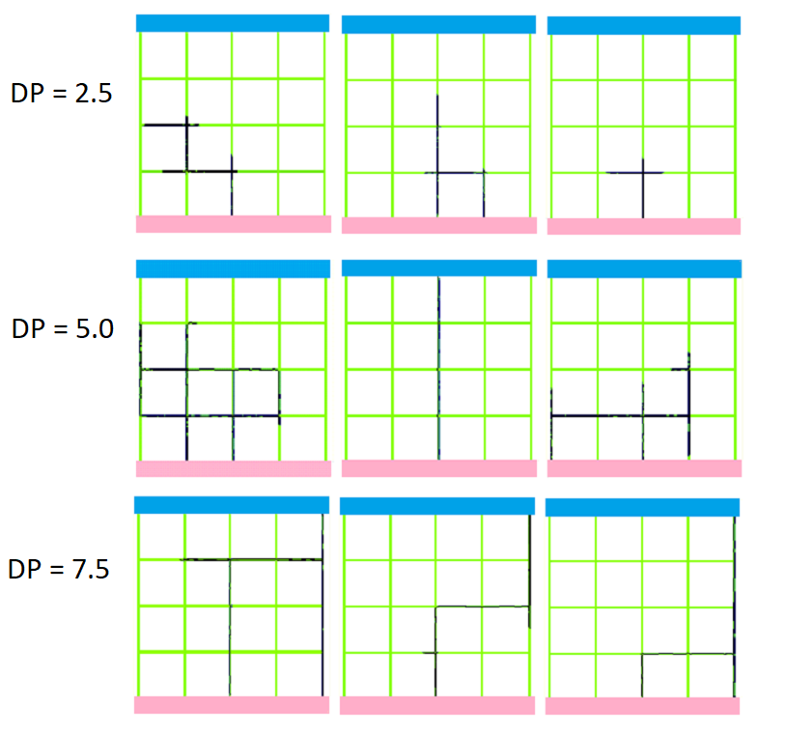

**Figure 2**: Nine panels each showing a single individual’s movement as predicted by the SMS through a TartanGraph system at three different values of Directional Persistence (DP; row states). Dark pixels indicate the path of travel for an individual originating in the bottom habitat patch. As DP is increased the simulated individual is more likely to make longer, straighter movements and less likely to double back on ground already covered.

Four values of DP (2.5, 5.0, 7.5 and 10.0) were simulated to test the hypothesis that increasing this parameter would produce a positive impact on the connectivity of *TartanGraph* systems irrespective of LLE characteristics. We anticipated this result because, in a *TartanGraph* system where the origin and destination patches are situated directly across from one another, we might expect that individuals who undertake straighter movements are more likely to successfully locate their dispersal goal before experiencing mortality in the hazardous environment of the LLE matrix.

Reproduction and dispersal across a period of 1010 years were simulated five times on each *TartanGraph* for each treatment of the DP parameter, providing 5050 years of data for each landscape / DP treatment. At the start of each simulation both habitat patches were initialised with a population of adult-stage individuals at half of the carrying-capacity of the patches. One of the outputs provided by the RangeShifter software is a *connectivity-matrix*, a yearly record of the number of individuals from each patch that successfully complete dispersal. The first ten years of each simulation were excluded from the data before analysis, as this covered the initialisation period of populations reproducing to attain equilibrium, leaving 5000 years of data for each *TartanGraph* for each treatment of DP. This data allowed comparison of connectivity between *TartanGraph* networks by quantifying the ease with which naïve individuals could navigate through networks of differing structure and complete dispersal in the novel patch.

Statistical Analysis

From the *connectivity-matrices*, we calculated a parameter of connectivity called *frequency* (Freq) for each *TartanGraph* under each treatment of DP as the number of years, out of the 5000 simulated, in which at least one individual successfully dispersed from one habitat patch into the other, in either direction. By comparing the values of Freq across different *TartanGraphs* under different simulation conditions we sought to distinguish any change in dispersal rates that appeared to correlate with alterations in the structure of LLE networks. We also used Freq to test our hypothesis that increasing the value of DP would generally increase dispersal rates within a *TartanGraph* system. Results from the first experimental set comprising 25 *TartanGraphs* were used to examine the effect of increasing the number of *connecting-edges* or *transecting-edges* on the value of Freq predicted by the SMS connectivity-matrices. Results from the second and third experimental sets were used to analyse how increasing the width of *connecting-edges* or *transecting-edges*, respectively, might impact connectivity.

Cell Visitation Heatmaps  
To further elucidate how simulated individuals behaved within *TartanGraphs* during simulations, we also made use of the *SMS Heatmap* function provided in RangeShifter v 2.0. The “heatmaps” produced by this function are raster images identical in dimension to the input landscape, where every non-habitat cell of the landscape is assigned a value counting the number of times during the total simulated time an individual moved through it during their dispersal attempts. Thus, on these heatmaps the “warmer” cells are those with higher values of visitation which individuals more frequently traversed during the simulated time period, whilst the “colder” cells are those with low values of visitation that were rarely entered by dispersers. Owing to the computational demand of heatmap generation, we limited this investigation to nine simulations; entering three *TartanGraphs*, all with five *connecting-edges* and differing numbers of *transecting-edges* (3, 7 and 15) individually into three simulations at different values of DP (2.5, 5.0 and 7.5). These simulations were run for 250 years and demography was parametrised as in the experiments already described.

Results

Matrix Network Density

The density and orientation of LLEs within the matrix of *TartanGraph* systems exerted a substantial impact on their ecological connectivity. Most strikingly, while the two different edge types (*connecting* and *transecting*) represented in the *TartanGraphs* both had substantial impacts, the direction of the impacts were opposite. This pattern was clearly seen across the first experimental set of 25 *TartanGraphs* where all edges had identical widths; the number of *connecting-edges* was strongly positively correlated with the degree of connectivity, whilst the number of *transecting-edges* was negatively correlated (**Figure 3**). From this first set, the *TartanGraph* whose structure was least conducive to successful dispersal was the one composed of 3 *connecting-edges* and 31 *transecting-edges*, producing a mean Freq of 22.3 across the four treatments of DP, meaning at least one individual achieved successful dispersal between the two habitat patches in only 0.4% of available years in simulation. Conversely, the *TartanGraph* whose structure resulted in the highest value of Freq had 33 *connecting-edges* and no *transecting-edges*, producing a mean Freq of 3395.8 across four DP treatments, experiencing successful dispersal of at least one individual in either direction in 67.9% of simulated years.

When examining the mean Freq of groups of five *TartanGraphs* sharing the same numbers of *connecting-edges* (3, 5, 9, 17 and 33 *edges*), we found that the near-doubling of the number of these features produced large positive changes in mean Freq for the first four treatments, ranging from a 22.7% increase (5 to 9 *connecting-edges*) to as great an increase as 52.8% (9 to 17 *connecting-edges*)*.* However, increasing the number of *connecting-edges* further from 17 to 33 appeared to deliver a diminishing return in connectivity, mean Freq being only 14.1% higher in the *TartanGraphs* with 33 *connecting-edges*. These results suggest that the ability to improve dispersal rates by adding more *connecting-edges* may approach a saturation point where additional LLEs will provide little or no benefit for facilitating movement across the network.

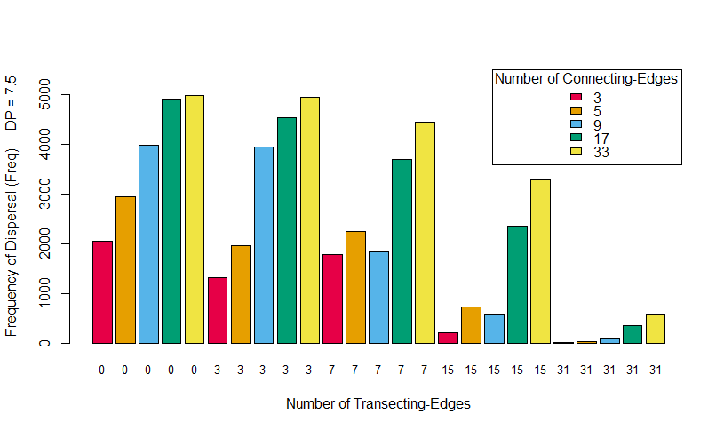

**Figure 3:** The Freq values produced by 25 TartanGraphs at DP value of 7.5. Each bar represents a single TartanGraph with a unique combination of numbers of **connecting** (indicated by the key) and **transecting** edges.

Examining the mean Freq of *TartanGraphs* sharing the same number of *transecting-edges* revealed that, in contrast to the diminishing returns of adding *connecting-edges*, greater *transecting-edge* numbers produced an increasingly disproportionate negative impact on connectivity. The mean connectivity of *TartanGraphs* decreased by 13.2% and 12.9% when the number of *transecting-edges* was raised from zero-to-three and from three-to-seven, respectively, marking a relatively small decline in connectivity observed between these first three *transecting-edge* treatments. However, across the next two treatments, raising *edge* numbers from seven to 15 and then from 5 to 31 *transecting-edges*, resulted in 44.5% and 79.7% declines in connectivity respectively. These results suggest that there may be a numerical threshold above which the inhibitory effect of *transecting-edges* and LLE intersections on dispersal rates becomes a serious detriment to individuals completing inter-patch dispersal, as the effect of near-doubling *transecting-edges* appears relatively mild across the initial treatments (0 to 3 to 7) but increasingly severe when the numbers of *edges* involved are much larger.

When individuals were parametrised to move with more correlated trajectories, successful dispersal between the two patches was higher: doubling DP from 2.5 to 5.0 resulted in an almost 40 times higher mean Freq (906.2 at DP = 5.0 and 3.8 at DP = 2.5) across the 25 *TartanGraphs*. Further increases in DP had smaller positive impacts on the likelihood of successful dispersal. Raising DP from 5.0 to 7.5 increased the mean Freq of all *TartanGraphs* by 155.0% (2311.12 at DP = 7.5) and a further raising DP to 10.0 increased mean Freq by 34.3% (3104.6 at DP = 10.0).

Width of Edges  
In the second set of 48 *TartanGraphs* where we experimentally altered *connecting-edge* widths we once again observed the same positive and negative correlations of Freq with the number of *connecting* and *transecting-edges*, respectively, as well as a less substantial correlation of *connecting-edge* width with connectivity. Increasing the width of the *connecting-edges* produced a weakly positive effect upon the mean values of Freq attained by the modified *TartanGraphs* (**Figure 4**).

Doubling the width of *connecting-edges* generally produced only a very small increase in connectivity, where the mean Freq (across all DP treatments) of the 16 *TartanGraphs* with four-cell wide *connecting-edges* was only 2.2% higher than in the 16 *TartanGraphs* composed of only two-cell wide LLEs. However, tripling the width of *connecting-edges* produced a substantial improvement in connectivity, with the mean Freq of *TartanGraphs* with six-cell wide *connecting-edges* being 24.4% larger than in *TartanGraphs* with narrow networks.

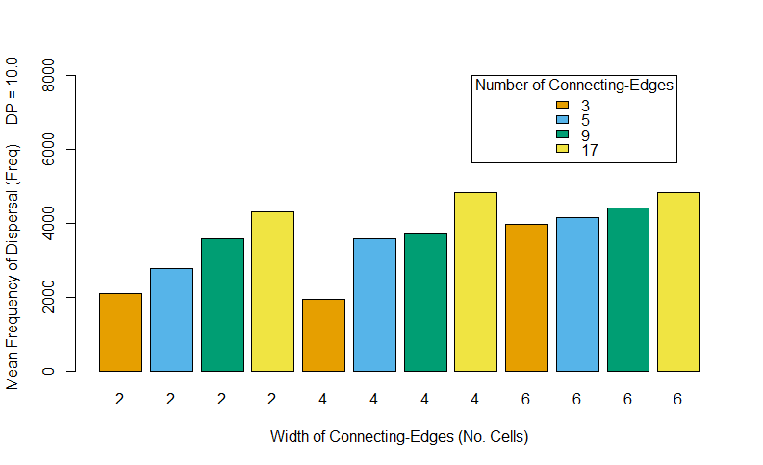 **Figure 4**: The mean Freq values of 48 TartanGraphs at DP 10.0. Each bar shows the mean Freq of a group of four TartanGraphs with different numbers of transecting-edges (0, 3, 7 and 15). Key indicates the number of connecting-edges in each group. X-axis indicates width (in cells) of connecting-edges.

The effect of widening *connecting-edges* was substantially different depending on the DP treatment (**Figure 5**.). At the two higher values of DP, *TartanGraphs* appeared to generally experience higher rates of dispersal when they had wider *connecting-edges*. At DP 10.0, the mean Freq of *TartanGraphs* increased by 10.2% when LLEs were doubled in width and by 36.3% when tripled in width. At DP 7.5, the mean Freq increased by 2.5% when *connecting-edge* width was doubled and by 27.3% when tripled. At the two lower values of DP, however, *TartanGraphs* with wider *connecting-edges* yielded lower dispersal. At DP 5.0 connectivity was 26.2% lower on *TartanGraphs* with doubly-wide *connecting-edges* and 23.9% lower on landscapes with triply-wide *connecting-edges*. At DP 2.5, mean Freq was 69.9% and 66.0% lower on *TartanGraphs* with *connecting-edges* of four and six cells wide, respectively, compared to those landscapes with two cell-wide LLEs. It appears that individuals parameterised to move in a straighter pattern were more likely to complete dispersal in a network with wide *connecting-edges*, but individuals that moved in a less correlated fashion were more likely to complete dispersal when *connecting-edges* were narrower.

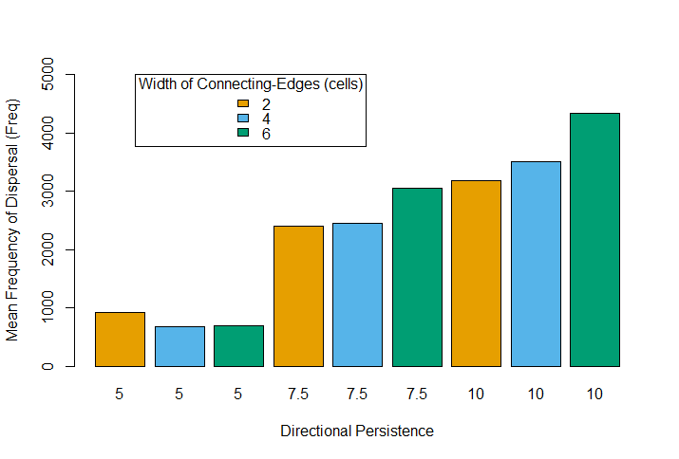

**Figure 5**: The mean Freq values of 48 TartanGraphs under different treatments of DP.

The third experimental set of 36 *TartanGraphs,* where we experimentally altered *transecting-edge* width, demonstrated a less ambiguous impact of edge width on connectivity, whereby wider *transecting-edges* resulted in lower rates of dispersal (**Figure 6**). Controlling for LLE numbers, we found that the mean Freq of 12 *TartanGraphs* with four-cell wide *transecting-edges* was 32.0% lower than of the same number of *TartanGraphs* where all LLEs were uniformly two cells wide. Likewise, the mean Freq of *TartanGraphs* with six-cell wide *transecting-edges* was 60.6% lower. The declines in connectivity associated with wider *transecting-edges* appeared to become more pronounced when the number of *transecting-edges* was greater. *TartanGraphs* with 7 *transecting-edges* exhibited declines in mean Freq of 32.3% and 77.2% when the width of *transecting-edges* was four or six cells-wide, respectively, whilst *TartanGraphs* with 15 *transecting-edges* exhibited mean Freq declines of 73.1% and 92.6% in conjunction with the same differences in edge width.

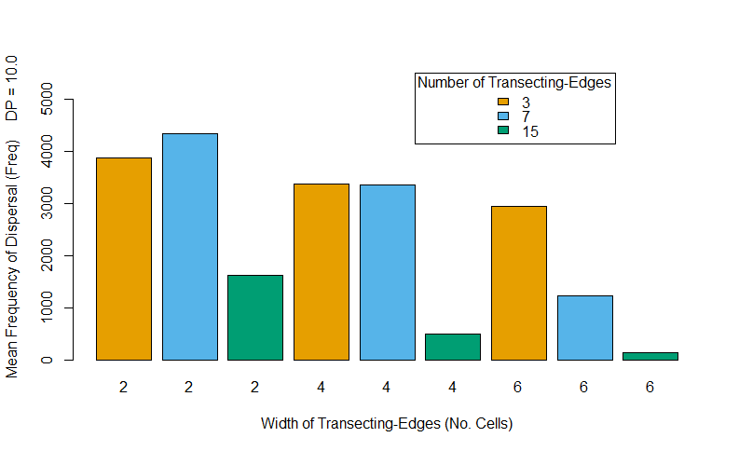 **Figure 6**: The mean Freq values of 36 TartanGraphs at DP 10.0. Each bar shows the mean Freq of a group of four TartanGraphs with different numbers of connecting-edges (3, 5, 9 and 17). Key indicates the number of transecting-edges.

Under higher treatments of the DP parameter, the negative impact of wider transecting-edges was less severe. The mean Freq of *TartanGraphs* with four-cell *transecting-edges* was 47.9% lower than those with two-cells at DP 5.0. At the higher DP values this discrepancy in mean Freq between the two treatments was smaller, where the connectivity of *TartanGraphs* with four-cell *transecting-edges* was 35.4% lower and 26.4% lower at DP 7.5 and 10.0, respectively. A similar pattern was observed when comparing the connectivity of *TartanGraphs* with six-cell and two-cell *transecting-edges* under different treatments of the DP parameter. These results demonstrate that though wider *transecting-edges* depressed the successful dispersal chances of individuals regardless of their movement preferences, this negative influence could nonetheless be partially mitigated by greater directional persistence on the part of dispersers.

Heatmap Results  
The “heatmaps” of selected *TartanGraphs* produced by the RangeShifter platform provide some insight into how movement of simulated individuals responded to changes in network structure.

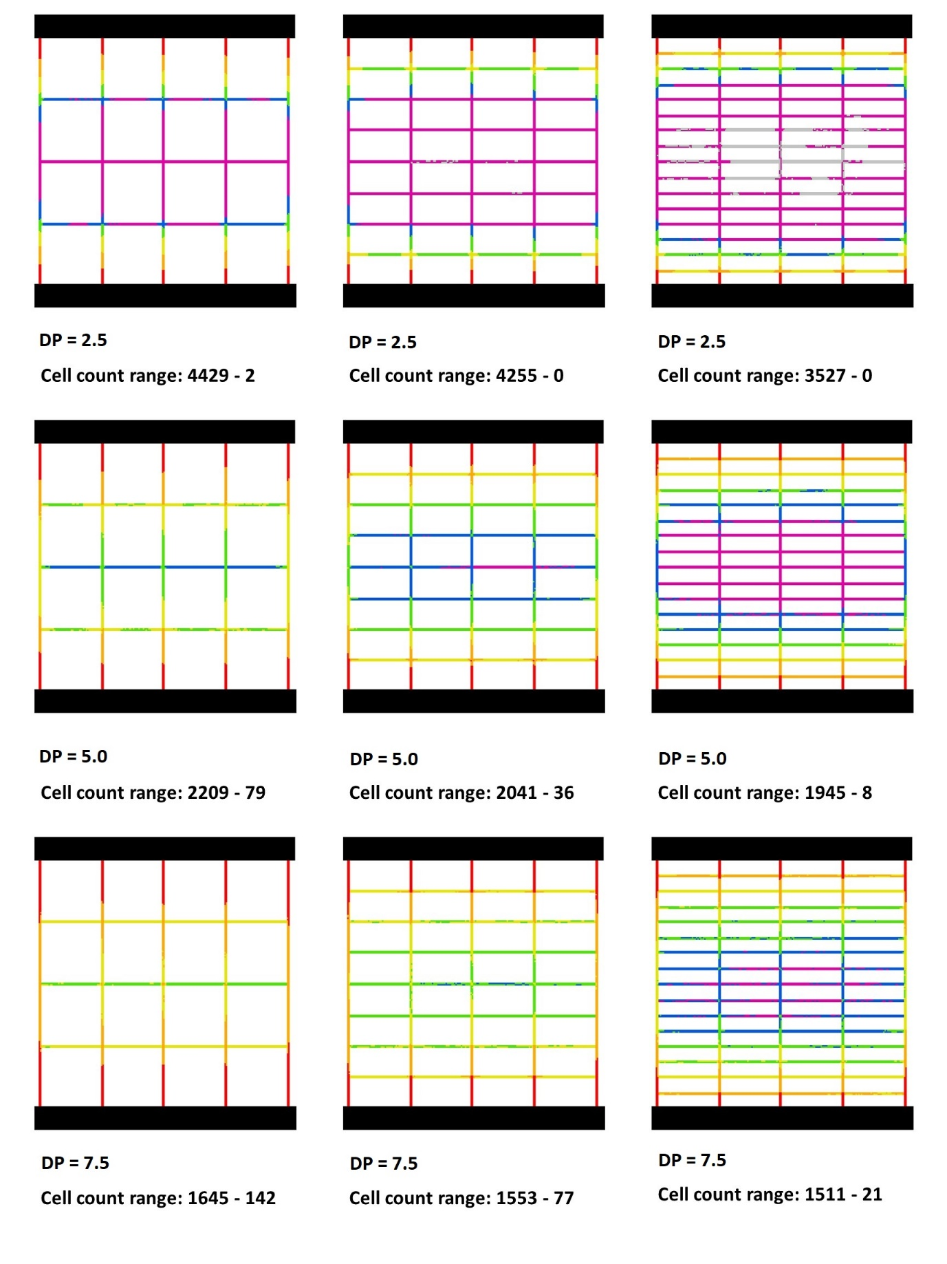

**Figure 7**: TartanGraph “Heatmaps” showing the number of times each matrix cell was visited by dispersing individuals throughout simulation. Cell values are colour-coded by percentage bands of the cell count range reported beneath each panel. **Red**: the highest count to 50.1%. **Orange**: 50 – 25.1%. **Yellow**: 25 – 12.6%. **Green**: 12.5 – 6.26%. **Blue**: 6.25 – 3.126%. **Purple**: 3.125 – 0.1%. **Grey**: no visitations / 0%. The DP values used to produce these results are indicated below each panel.

In the nine heatmaps produced from three different *TartanGraphs* (**Figure 7**.), LLE cells located closer to the habitat patches where more often visited by dispersing individuals throughout simulations than those located in the centre of the landscape, regardless of the DP treatment or the composition of the high-quality LLE matrix. This suggests that penetration of the network by individuals was sufficiently challenging to produce a noticeable decline in visitation frequency further from the habitat patches, and that, whether due to mortality or misdirection of individuals back toward their natal patches, only a fraction of dispersers were able to move at least halfway across the landscape in either direction and complete dispersal by locating the opposite patch.

As DP was increased, visitation counts across the LLE networks flattened, as cells close to the habitat patches “cooled” due to lower visitation counts during dispersal and those located in the centre of the landscapes “warmed” as more individuals penetrated deeper into the network. The “cooling” of cells located closer to habitat patches can be observed in the declining maximum visitation count recorded in the raster cell values and the “warming” of centrally-located cells can be observed in the raising of the minimum recorded visitation values. At the lowest value of DP, some cells received no visitations during the whole simulation (cells coloured grey in **Figure 7**). These results indicate that movements of individuals across the *TartanGraph* networks became more evenly distributed as their movement trajectories became more correlated, as individuals of a higher DP appeared to spend less time in the cells adjacent to natal habitat patches and to be more likely to penetrate deeper into the core of the LLE network during dispersal.

The results of the heatmaps indicate that the addition of more *transecting-edges* to *TartanGraphs* had the effect of reducing visitations in the central area of the LLE network. *TartanGraphs* with higher numbers of *transecting-edges* had consistently lower minimum visitation counts, and **Figure 7** demonstrates that, when controlling for DP, there was a “cooling” of *connecting-edges* in the centre of the matrix when they have more intersections with *transecting-edges*. These results indicate that less movement occurred through the centre of *TartanGraph* networks with higher numbers of *transecting-edges*, suggesting that fewer dispersers travelled through the centre of *connecting-edges* when they were more intersected by perpendicular LLEs. It is also demonstrated in **Figure 7** that the connecting-edges that formed the boundary of the LLE network experienced noticeably more visitations than those located more centrally. The higher rates of visitation observed in these LLEs may be the result of individuals travelling through *transecting-edges* encountering the edge of the landscape, and upon emerging in the lateral-most *connecting-edges* were compelled to move up or down their lengths to continue dispersal. This identifies the lateral-most *connecting-edges* as important features for promoting movement through the centre of the *TartanGraphs* and may indicate that they acted as the primary dispersal corridors for simulated individuals.

Discussion

The findings of this investigation suggest that the greater freedom of movement offered by linear features that act as dispersal corridors can negatively impact a landscape’s connectivity by increasing the likelihood of dispersing individuals becoming lost in the matrix and thereby demographically isolating embedded habitat patches. Though previous in-silico studies have examined the effect of creating novel LLEs to connect habitat patches, these focused on the addition of single patch-to-patch corridors within a landscape of many habitat patches (Lefkovitch and Fahrig, 1985; Anderson and Danielson, 1997; Delattre *et al*., 2010). We simulated two-patch systems connected by networks of intersecting LLEs to examine the effect of adding multiple corridors between two habitats and the impact of LLE nodes on movement patterns. Our results appear to demonstrate that LLEs can act as “traps” for dispersing individuals, depressing connectivity by channelling dispersers away from habitat patches and increasing the risk of mortality for individuals attempting to traverse the network. The potential for linear features to adversely impact connectivity by acting as sinks has been previously theorised by landscape ecologists (Saunders and Hobbs, 1991; Simberloff *et al*., 1992) and empirical research of invertebrate assemblages in LLEs suggests that they can be demographic sinks for source populations in nearby habitat patches (Öckinger & Smith, 2007; Krewenka *et al*., 2011). By simulating individual dispersal through a permeable yet uninhabitable network, we have demonstrated this hypothesised LLE-sink dynamic in-silico, and attained results suggesting that in some cases increasing the number of linear elements may, depending on their spatial orientation, have counter-productive effects on LLE-network connectivity.

An explanation for this important result may be found in the empirical results reported by Eriksson *et al*. (2013). They demonstrated that a node formed by intersecting LLEs caused an approximately 50/50 division of dispersing crickets into individuals that maintained direction and moved past the node and those who changed direction and moved into the transecting LLE. By assuming a limited perception of environment and a stochastic pattern of decision-making on the part of dispersers, the SMS replicated this tendency of individuals in nature to exploit the freedom of movement offered by nodes, whether to the benefit or detriment of their dispersal outcomes. As *transecting-edges* would permit individuals to make lateral movements across the landscape but provide no additional routes by which they could approach either patch (indeed preventing patch-approach along their lengths between nodes), movements through them would have been unproductive toward dispersal aims whilst nonetheless extracting a movement-cost. The SMS may have simulated the negative correlation between *transecting-edge* density and dispersal as the result of more individuals expiring in the matrix, anticipating that a subset of them would initiate movement into *transecting-edges* at each additional node and thereafter encounter further per-step mortality risks as they conducted unproductive lateral movements across the *TartanGraph*. The results of our heatmaps lend some credence to this explanation, as shown by both the lower visitation rates of centrally-located matrix cells in *TartanGraphs* with more *transecting-edges*, and by the higher visitation rates in *transecting-edges* located adjacent to the habitat patches. The lower rates of movement through the centre of *connecting-edges* when intersected by more *transecting-edges* also suggests individuals used nodes to leave *connecting-edges* before travelling their full length and helps account for the smaller dispersal rates through networks with more *transecting-edges*.

Our hypothesis that increasing the DP of individuals would improve dispersal rates was supported by the results. In-silico experiments have demonstrated that a greater autocorrelation in individual movement increases the dispersal-potential of populations across homogenous areas (such as our *TartanGraphs* LLEs), because these individuals can attain greater distances under constraints on movement, such as timeframe or movement-costs (Cain, 1991; Tischendorf and Wissel, 1997). Thus, in our system, high-DP individuals may have made more efficient use of LLEs during movement, closing the distance to novel habitat patches in a smaller number of steps than low-DP individuals, who might have made more diversionary movements through LLEs. It is also possible that high-DP individuals were less likely to make use of intersections to move between LLEs and a lower propensity to use nodes to change direction might have contributed to their greater dispersal rates independent of their greater efficiency of movement through LLEs (see **Figure 2**.). Though mean Freq showed a broadly linear decline with increasing numbers of *transecting-edges* (and nodes), the improvement in connectivity generated by increasing DP from 5.0 to 10.0 was greater on *TartanGraphs* containing three or seven *transecting-edges* (an increase in mean Freq of +2599 and +31789, respectively) than those containing no *transecting-edges* and therefore no nodes (mean Freq: +2379). The greater improvement of connectivity on *TartanGraphs* with an intermediate density of nodes may be evidence that dispersal rates were higher for high-DP individuals due not only to more efficient movement through all LLEs, but also to their lower likelihood of entering *transecting-edges* through nodes and being drawn by network structure into making unproductive movements.

Based on the results of these simulations it appears LLEs exerted a highly focussed and unidirectional impact on connectivity whereby they significantly increased matrix permeability along their axes but restricted perpendicular movements. As *transecting-edges* only increased the permeability of *TartanGraphs* along a lateral axis that intersected with neither of the parallel habitat patches, they appear to have reduced the connectivity of the landscape by opening the potential for individuals to make costly movements that could make no progress toward dispersal aims. These results suggest how LLEs may facilitate or inhibit movement across landscapes depending on their orientation, as well as how decisions made by individuals at focal points (LLE intersections) might powerfully impact patterns of movement over broad areas of a landscape overlain with an LLE network.

The effect of widening either edge type appears to produce a similar though sometimes weaker effect on dispersal as increasing LLE numbers. The *TartanGraphs* that possessed wider *connecting-edges* generally experienced greater connectivity than those with the same number of narrower LLEs. The results of other in-silico studies have also suggested that wider corridors are more conducive to facilitating connectivity along their lengths (Baur and Baur, 1992; Tischendorf *et al*., 1998; Delattre *et al*., 2010; Christies and Knowles, 2015) as wider corridors offer less resistance to movement by lowering the chance of dispersers encountering the corridor’s boundaries or edge elements (Tischendorf and Wissel, 1997). However, we found that increasing the width of *connecting-edges* had a weakly positive impact on connectivity only when individuals were parameterised with the two higher values of DP (**Figure 5**.), and wider *connecting-edges* in some cases appeared to inhibit connectivity for low-DP populations. For low-DP populations, the positive effects of increased corridor width may have been offset by the greater freedom of lateral movement permitted by a broad *connecting-edge*, allowing individuals to make meandering movements along the LLE that resulted in less efficient use of *connecting-edges* to traverse the landscape. Empirical studies on the movement of animals through corridors of different widths reveals potential real-world parallels to our simulation results. Andreassen *et al*. (1996) found that released voles most successfully used a corridor measuring one metre in width to disperse to new habitat patches, higher than both a narrower corridor (0.4m width) and a wider corridor (3m). This discovery that the intermediate width corridor best facilitated movement is interesting, and the authors suggest that cross-sectional movements on the part of voles inside the wide corridor may explain their lower movement rates therein. Similarly, Kowalski *et al*. (2019) found that voles moved faster through narrower grassy corridors than in other treatments, and Pryke and Samways (2001) observed that vagile butterfly species moved faster through narrow and disturbed grassland corridors than wider ones. Findings such as these present an alternative understanding of how corridor boundaries might impact dispersers, suggesting that rather than a consistently negative effect of boundary encounters on progress through a corridor, boundaries situated at close proximity may serve to channel dispersers through faster than if they were wider apart (Tischendorf and Wissel, 1997). Such a boundary-channelling dynamic may account for why dispersal rates of our low-DP individuals were sometimes higher on *TartanGraphs* with narrower *connecting-edges* and highlights how behavioural factors at the individual level can interact with landscape structure to influence wider movement patterns (Lima and Zollner, 1996; Coulon *et al*., 2015).

Our findings highlight the importance of incorporating behavioural variables into models of dispersal in order to detect sometimes unintuitive consequences of landscape structure on connectivity. Predicted dispersal rates through *TartanGraphs* derived from least-cost theory would have been identical for all network configurations, as inter-patch distance and resistance of the LLEs to movement were controlled for in landscape design. Thus, only by incorporating a limited perceptual range and memory retention on the part of individual dispersers did the SMS identify the sink function exerted by some LLEs, as many naïve individuals used nodes to enter LLEs with no knowledge of whether the corridor brought them closer or further from their goal. In-silico studies using an individual-based approach have previously shown that the addition of features to landscapes designed to promote connectivity can have the opposite effect. In the case of “stepping stones”, small patches of novel habitat designed to encourage movement between larger remnant patches, in-silico studies found that when individual-based behaviour was taken into account the steeping stones could have a disruptive effect on dispersal rates by encouraging individuals to settle in the sub-optimal novel habitat (Hein *et al*., 2004; Kramer-Schadt *et al*., 2011). Like our *transecting-edges*, these stepping stones might have been expected to improve connectivity by easing the overall resistance of the landscape to movement. However, precluded as they are from an ecologist’s view of the landscape, individuals in nature react to landscape structure within a limited range of comprehension and may use permeable features in ways that cause wild populations to forgo making full use of available landscape resources.

These insights are particularly valuable given the increasing interest in the use of conservation corridors to facilitate connectivity and movements of wildlife between parts of the landscapes (Hilty *et al*., 2021). Improving connectivity is an intrinsic part of the international community’s response to the biodiversity and climate change crises (Saura *et al*., 2018). In countries with large-scale intensive agriculture, like the UK, where the landscape is criss-crossed by field boundaries made up of hedgerows or ditches, this research is particularly useful. For example, current guidance on the design of corridors as part of England’s plans for the development of national Nature Recovery Network did not consider the possible impacts of how conservation corridors could act as a hindrance to dispersal if effectively providing cul-de-sacs for dispersing individuals (Crick *et al*., 2020).

Conclusion

According to our results, the number, width and orientation of the LLEs that compose an intersecting network can have significant and sometimes counter-intuitive impacts on connectivity. By taking an individual-based approach, we found that connectivity might be negatively impacted by the greater freedom of movement offered by LLEs and their intersections, as dispersers were vulnerable to being drawn into sinks where they would expire from movement costs. Increasing the width of LLEs exerted a similar effect on predicted dispersal as increasing LLE numbers, though the beneficial effect of increasing *connecting-edge* width was weaker than increasing their number. Wide LLEs allow greater movement of high-DP dispersers, but narrower LLEs may in some instances better promote the movement of low-DP dispersers through channelling effects. The results of this study provide further evidence of the utility of individual-based methods to investigate how the creation of novel elements may improve landscape permeability but can also harm connectivity over larger spatial scales by orienting individuals away from optimal habitats and landscape resources.

Acknowledgements

We would like to thank the Natural Environment Research Council and Natural England for providing the funding to conduct this study. We are also indebted to the work of Greta Bocedi in developing the RangeShifter platform prior to its implementation in this study.

**References**

Anderson GS, Danielson BJ (1997) The effects of landscape composition and physiognomy on metapopulation size: the role of corridors. Landscape Ecol 12:261-271

Andreassen HP, Halle S, Ims RA (1996) Optimal width of movement corridors for root voles: not too narrow and not too wide. J Appl Ecol 33:63-70

Baldock D (1990) Agriculture and habitat loss in Europe. CAB Direct. <https://www.cabdirect.org/cabdirect/abstract/19901884403>. Accessed 21 May 2021.

Baur A, Baur B (1992) Effect of corridor width on animal dispersal: a simulation study. Global Ecol Biogeogr 2**:**52-56

Bocedi G, Palmer SCF, Pe’er G, Heikkinen RK, Matsinos YG, Watts K, Travis JMJ (2014) RangeShifter: a platform for modelling spatial eco-evolutionary dynamics and species’ responses to environmental changes. Meth Ecol Evol 5**:**388–396

Brown JH, Kodric-Brown A (1977) Turnover rates in insular biogeography: effect of immigration on extinction. Ecology 58**:**445-449

Cain ML (1991) When do treatment differences in movement behaviours produce observable differences in long-term dis- placements? Ecology 72:2137-2142

Christie MR, Knowles LL (2015) Habitat corridors facilitate genetic resilience irrespective of species dispersal abilities or population sizes. Evol Appl 8**:**454-463

Coulon A, Aben J, Palmer SCF, Stevens VM, Callens T, Strubbe D, Lens L, Matthysen E, Baguette M, Travis JMJ (2015) A stochastic movement simulator improves estimates of landscape connectivity. Ecology 96 (8):2203-2213

Crick HQP, Crosher IE, Mainstone CP, Taylor SD, Wharton A, Langford P, Larwood J, Lusardi J, Appleton D, Brotherton PNM, Duffield SJ, Macgregor NA (2020) Nature Networks Evidence Handbook. Natural England Research Report NERR081. Natural England. York.

Delattre T, Pichancourt JB, Burel F, Kindlmann P (2010) Grassy field margins as potential corridors for butterflies in agricultural landscapes: A simulation study. Ecol Model 221:370-377

Ekroos J, Rundolf M, Smith HG (2013) Trait-dependent responses of flower-visiting insects to distance to semi-natural grasslands and landscape heterogeneity. Landscape Ecol 28 (7):1283-1292

Eriksson A, Low M, Berggren A (2013) Influence of linear versus network corridors on the movement and dispersal of the bush-cricket *Metrioptera roeseli* (Orthoptera: Tettigoniidae) in an experimental landscape. Euro J Etymol 110 (1):81-86

Fahrig L (1997) Relative effects of habitat loss and fragmentation on population extinction. J Wildlife Manage 61(3):603-610

Fahrig L (2003) Effects of habitat fragmentation on biodiversity. Annu Rev Ecol Evol S 34:487-515

Fahrig L, Merriam G (1985) Habitat patch connectivity and population survival. Ecology 66 (6):1762-1768

Fahrig L, Merriam G (1994) Conservation of fragmented populations. Conserv Biol 8 (1):50-59

Forman RTT, Gordon M (1981) Patches and Structural Components for a Landscape Ecology. BioScience 31 (10):733-740

Graham L, Gaulton R, Gerard F, Staley JT (2018) The influence of hedgerow structural condition on wildlife habitat provision in farmed landscapes. Biol Conserv 220:122-131

Hanski I, Ovaskainen O (2000) The metapopulation capacity of a fragmented landscape. Nature 404: 755-758

Hansson L (1991) Dispersal and connectivity in metapopulations. Biol J Linn Soc 42:89-103

He F (2009) Price of prosperity: economic development and biological conservation in China. J Appl Ecol 46:511-515

Hein S, Pfenning B, Hovestadt T, Poethke HJ (2004) Patch density, movement pattern, and realized dispersal distances in a patch-matrix landscape—a simulation study. Ecol Model 174:411–420

Henderson MT, Merriam G, Wegner J (1985) Patchy environments and species survival: Chipmunks in an agricultural mosaic. Biol Conserv 31 (2):95-105

Hilty J, Worboys GL, Keeley A, Woodley S, Lausche B, Locke H, Carr M, Pulsford I, Pittock J, White JW, Theobald DM, Levine J, Reuling M, Watson JEM, Ament R, Tabor GM (2020) Guidelines for conserving connectivity through ecological networks and corridors. Best Practice Protected Area Guidelines 30 Gland, Switzerland: IUCN

Jauker F, Diekötter T, Schwarzbach F, Wolters V (2009) Pollinator dispersal in an agricultural matrix: opposing responses of wild bees and hoverflies to landscape structure and distance from main habitat. Landscape Ecol 24**:**547-555

Joyce KA, Holland JM, Doncaster CP (1999) Influences of hedgerow intersections and gaps on the movement of carabid beetles. B Entomol Res 89**:**523-531

Kramer-Schadt S, Kaiser TS, Frank K, Wiegand T (2011) Analyzing the effect of stepping stones on target patch colonisation in structured landscapes for Eurasian lynx. Landscape Ecol 26**:**501–513

Krewenka KM, Holzschuh A, Tscharntke T, Dormann CF (2011) Landscape elements as potential barriers and corridors for bees, wasps and parasitoids. Biol Conserv 144:1816-1825

Kowalski GJ, Grimm V, Herde A, Guenther A, Eccard JA (2019) Does animal personality affect movement in habitat corridors? Experiments with common voles (*Microtus arvalis*) using different corridor widths. Animals 9 (291)

Lande R (1993) Risks of population extinction from demographic and environmental stochasticity and random catastrophes. Am Nat 142 (6):911-927

Lefkovitch LP, Fahrig L (1985) Spatial characteristics of habitat patches and population survival. Ecol Model 30:297-308.

Lima SL, Zollner PA (1996) Towards a behavioral ecology of ecological landscapes. Trends Ecol Evol 11 (3):131-135

Mader HJ, Schell C, Kornacker P (1990) Linear barriers to arthropod movements in the landscape. Biol Conserv 54:209-222

Mech SG, Hallett JG (2001) Evaluating the effectiveness of corridors: a genetic approach. Conserv Biol 15 (2):467-474

Merckx T, Feber RE, McLaughlan C, Bourn NAD, Parsons MS, Townsend MC, Riordan P, McDonald DW (2010) Shelter benefits less mobile moth species: The field-scale effect of hedgerow trees. Agr Ecosyst Environ 138:147-151

Newman D, Pilson D (1997) Increased probability of extinction due to decreased effective population size: experimental populations of *Clarika pulchella.* Evolution 51 (2):354-362

Ökinger E, Smith HG (2007) Semi-natural grasslands as population sources for pollinating insects in agricultural landscapes. J Appl Ecol 44:50-59

Ovaskainen O, Meerson B (2010) Stochastic models of population extinction. Trend Ecol Evol 25 (11):643-652

Palmer SCF, Coulon A, Travis JMJ (2011) Introducing a ‘Stochastic Movement Simulator’ for estimating habitat connectivity. Meth Ecol Evol 2: 258-268

Pryke SR, Samways MJ (2001) Width of grassland linkages for the conservation of butterflies in South African afforested areas. Biol Conserv 101**:**85-96

Saunders DA, Hobbs RJ (1991) The role of corridors in conservation: what do we know and where to we go? In: Nature Conservation 2: The Role of Corridors. Surrey Beatty & Sons. Chipping Norton. pp 421-427

Saunders DA, Hobbs RJ, Margules CR (1991) Biological consequences of ecosystem fragmentation: a review. Conserv Biol 5 (1):18-32

Saura S, Bertzky B, Bastin L, Battistella L, Mandrici A, Dubois G (2018) Protected area connectivity: Shortfalls in global targets and country-level priorities. Biol Conserv 219:53–67

Scanes CG (2018) Chapter 19 - Human Activity and Habitat Loss: Destruction, Fragmentation and Degradation. In: Animals and Human Society. Academic Press. London. pp 451-482

Schulp CJE, Lautenbach S, Verburg PH (2014) Quantifying and mapping ecosystem services: Demand and supply of pollination in the European Union. Ecol Indic 36**:**131-141

Simberloff D, Farr JA, Cox J, Mehlman DW (1992) Movement Corridors: Conservation Bargains or Poor Investments? Conserv Biol 6 (4):493-504

Taylor PD, Fahrig L, Henein K, Merriam G (1993) Connectivity Is a Vital Element of Landscape Structure. Oikos 68 (3):571-573

Tischendorf L, Irmler U, Hingst R (1998) A simulation experiment on the potential of hedgerows as movement corridors for forest carabids. Ecol Model 106:107-118

Tischendorf L, Wissel C (1997) Corridors as conduits for small animals: attainable distances depending on movement pattern, boundary reaction and corridor width. Oikos 79**:**603-611

Van Geert A, Van Rossum F, Treist L (2010) Do linear landscape elements in farmland act as biological corridors for pollen dispersal? J Ecology 98 (1):178-187

Villemey A, Van Halder I, Ouin A, Barbaro L, Chenot J, Tessier P, Calatayud F, Martin H, Roche P, Archaux F (2015) Mosaic of grasslands and woodlands is more effective than habitat connectivity to conserve butterflies in French farmland. Biol Conserv 191:206-215